KIND ATTN : CDMA CSR Users :

In case of RUIM the data plan provisioning is now made feasible.
1.] Following same data packages are applicable for RUIM type cards
a.)Postpaid EVDO 750 Plan
b.)Postpaid NIC 350 Plan
c.)Prepaid EVDO
d.)Prepaid NIC
e.)Prepaid Voice and Data on HHT

Detail procedure attached herewith.

The offline created numbers pl be given to circle office in the prescribed format [ in Excel File] attached herewith. The circle office (MH/MP/GJ/CHG) will provide the consolidated list to B&CCS. for bulk creation with following active dates :

MH :01/09/2010
MP&CHG :06/09/2010
GJ :08/09/2010

Regards,

VSPHIRKE,
SDE(B&CCS),
O/o DGM(Mobile B&CCS),
MHS Bldg,Pune-1.
020-26353422
9423144445

KIND ATTN : CDMA CSR Users :

In case of RUIM the provisioning is to be done
1.] Following same data packages are applicable for RUIM type cards
a.) Postpaid EVDO 750 Plan
b.)Postpaid NIC 350 Plan
c.)Prepaid EVDO
d.)Prepaid NIC
e.)Prepaid Voice and Data on HHT

2.] Only the inventory line to be selected as that of RUIM.

Inventory line to be selected as follows as it was being done for offline Prepaid creation.

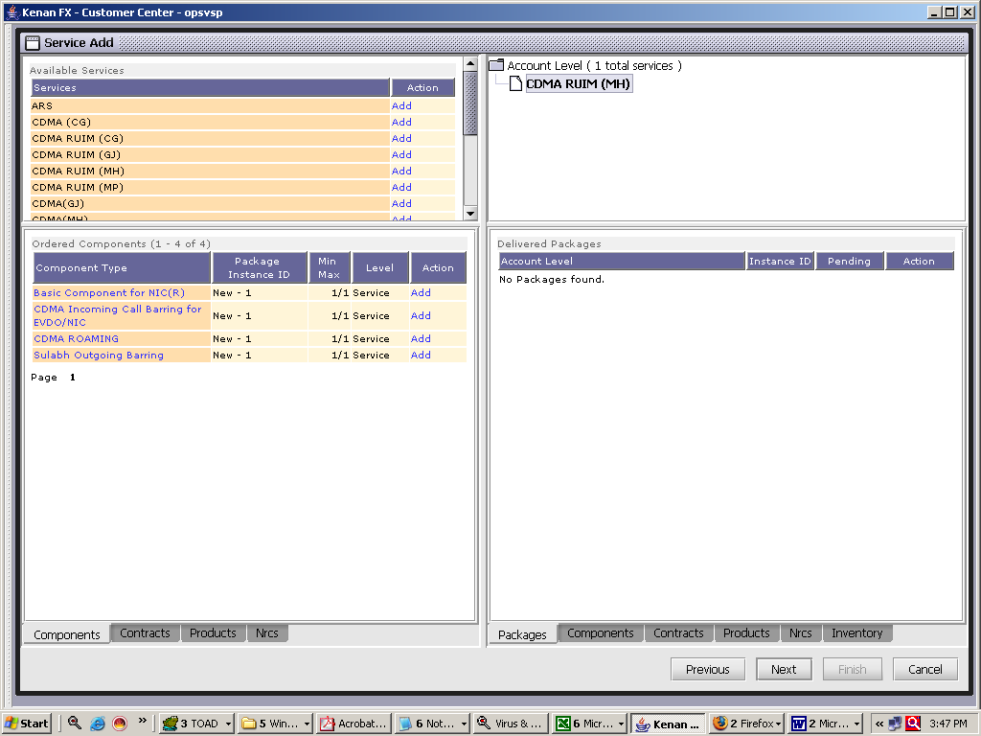

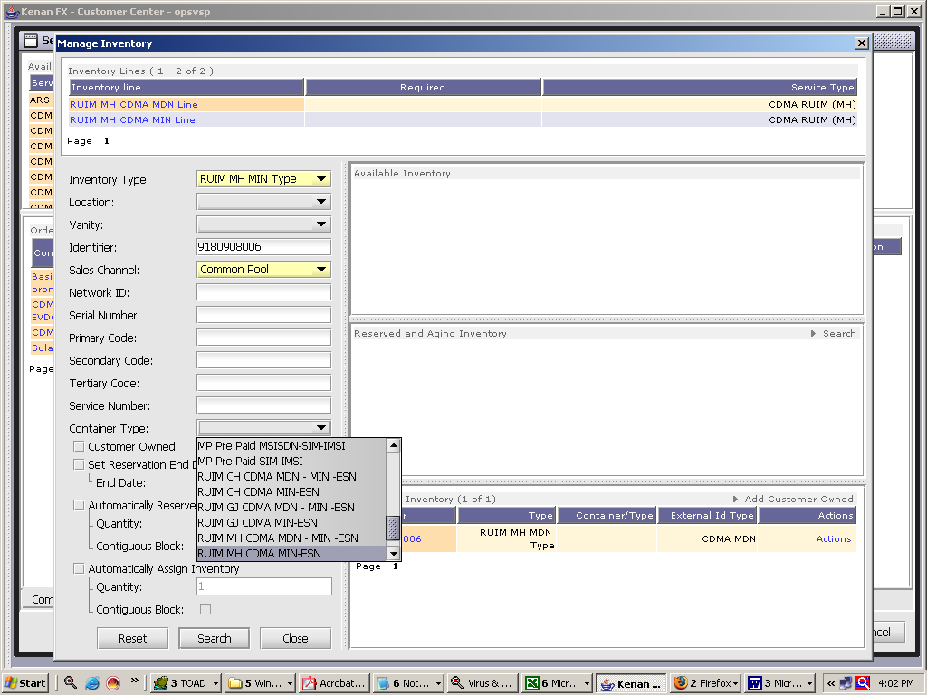

The offline created numbers pl be given to circle office in the prescribed format attached herewith. The circle office (MH/MP/GJ/CHG) will provide the consolidated list to B&CCS. for bulk creation with following active dates :
MH :01/09/2010
MP&CHG : 06/09/2010
GJ :08/09/2010

:

